**06 - Competitive Programming**

|  |  |
| --- | --- |
| **Ex. No. : 6.1** | **Date: 17.09.24** |
| **Register No.: 230701363** | **Name: D.THEEPAK PALANI KUMAR** |



AIM:

**Find Duplicate in Array.**

**Given a read only array of n integers between 1 and n, find one number that repeats.**

**Input Format:**

**First Line - Number of elements n Lines - n Elements**

**Output Format:**

**Element x - That is repeated For example:**

|  |  |
| --- | --- |
| **Input** | **RESULT** |
| **5**  **1 1 2**  **3 4** | **1** |

ALGORITHM:

Step 1: Start

Step 2: Read the value of n from the user and initialize an array arr of size n. Read n integer values into the array.

Step 3: Iterate through each element in the array. For each element, set temp to the current element and initialize j to the current index.

Step 4: Inside a while loop, check if the current element temp is equal to the next element in the array. If they are equal, set flag to 1 and break out of the loop.

Step 5: If flag is 0 after the inner loop, continue to the next iteration. If flag is 1, print the duplicate value temp and break the outer loop.

Step 6: End

PROGRAM:

#include<stdio.h> int main()

{

int n,a,flag=0; scanf("%d",&n); int arr[n]; for(int i=0;i<n;i++){ scanf("%d",&a); arr[i]=a;

}

for(int i=0;i<n;i++)

{

int j=i; int temp=arr[j]; while(j<n)

{

if(temp==arr[j+1]){ flag=1; break;

}

else j++;

}

if(flag==0) continue; else{ printf("%d",temp); break;

}}}

OUTPUT:

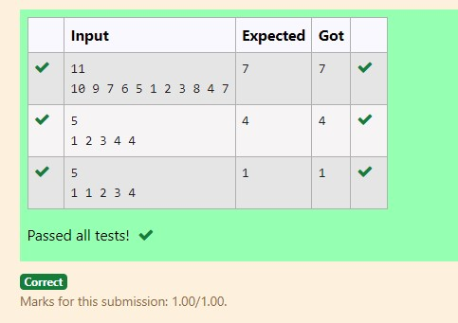

RESULT:

Hence the above program has been executed successfully.

|  |  |
| --- | --- |
| **Ex. No. : 6.2** | **Date: 17.09.24** |
| **Register No.: 230701363** | **Name: D.THEEPAK PALANI KUMAR** |



AIM:

**Find Duplicate in Array.**

**Given a read only array of n integers between 1 and n, find one number that repeats.**

**Input Format:**

**First Line - Number of elements n Lines - n Elements**

**Output Format:**

**Element x - That is repeated For example:**

|  |  |
| --- | --- |
| **Input** | **RESULT** |
| **5**  **1 1 2**  **3 4** | **1** |

ALGORITHM:

Step 1: Start

Step 2: Read the value of n from the user and declare an array arr of size n.

Step 3: Read the first value into t and assign it to arr[0].

Step 4: Iterate from index 1 to n-1, reading values into arr[i]. If the value of t matches arr[i], break the loop. Otherwise, update t to arr[i].

Step 5: After the loop, print the value of t.

Step 6: End

PROGRAM:

#include<stdio.h> int main()

{

int n,t; scanf("%d",&n); int arr[n]; scanf("%d",&t); arr[0]=t; for(int i=1;i<n;i++){ scanf("%d",&arr[i]); if(t==arr[i]) break; else t=arr[i];

}

printf("%d",t);

}

OUTPUT:

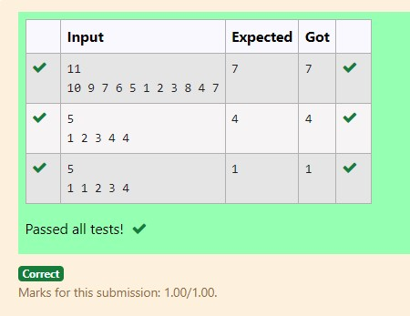

RESULT:

Hence the above program has been executed successfully.

|  |  |
| --- | --- |
| **Ex. No. : 6.3** | **Date: 17.09.24** |
| **Register No.: 230701363** | **Name: D.THEEPAK PALANI KUMAR** |



AIM:

Find the intersection of two sorted arrays. OR in other words,

Given 2 sorted arrays, find all the elements which occur in both the arrays.

Input Format

· The first line contains T, the number of test cases. Following T lines contain:

1. Line 1 contains N1, followed by N1 integers of the first array
2. Line 2 contains N2, followed by N2 integers of the second array

Output Format

The intersection of the arrays in a single line

Example

Input:

1

3 10 17 57

6 2 7 10 15 57 246

Output:

10 57

Input:

1

6 1 2 3 4 5 6

2 1 6

Output:

1 6

ALGORITHM:

Step 1: Start

Step 2: Read the number of test cases, t

Step 3: For each test case, read the sizes n1 and n2 and the elements of the arrays arr1 and arr2

Step 4: For each element in arr1, check if it exists in arr2. If it does, print the element

Step 5: End

PROGRAM:

#include <stdio.h> void intersection(int arr1[],int n1,int arr2[],int n2){ for (int i=0;i<n1;i++){ int element=arr1[i]; for (int j=0;j<n2;j++){ if (arr2[j]==element) { printf("%d ",element); break;

}

}

}

printf("\n");

}

int main(){ int t; scanf("%d",&t); while(t--){ int n1,n2; scanf("%d",&n1); int arr1[n1]; for(int i=0;i<n1;i++){ scanf("%d",&arr1[i]);

}

scanf("%d",&n2); int arr2[n2]; for(int i=0;i<n2;i++){ scanf("%d",&arr2[i]);

}

intersection(arr1,n1,arr2,n2);

}

}

OUTPUT:

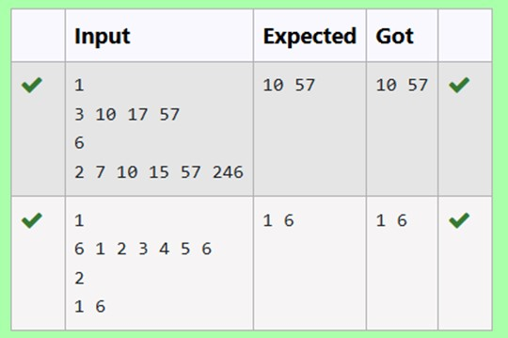

RESULT:

Hence the above program has been executed successfully.

|  |  |
| --- | --- |
| **Ex. No. : 6.4** | **Date: 17.09.24** |
| **Register No.: 230701363** | **Name: D.THEEPAK PALANI KUMAR** |



AIM:

Find the intersection of two sorted arrays. OR in other words,

Given 2 sorted arrays, find all the elements which occur in both the arrays.

Input Format

· The first line contains T, the number of test cases. Following T lines contain:

1. Line 1 contains N1, followed by N1 integers of the first array
2. Line 2 contains N2, followed by N2 integers of the second array

Output Format

The intersection of the arrays in a single line

Example

Input:

1

3 10 17 57

6 2 7 10 15 57 246

Output:

10 57

Input:

1

6 1 2 3 4 5 6

2 1 6

Output:

1 6

ALGORITHM:

Step 1: Start

Step 2: Read the number of test cases, t

Step 3: For each test case, read the sizes n1 and n2, then read elements of the arrays arr1 and arr2

Step 4: Use two pointers to iterate through arr1 and arr2, printing the common elements

Step 5: End

PROGRAM:

#include <stdio.h> void intersection(int arr1[], int n1, int arr2[], int n2) { int i=0,j=0; while (i<n1 && j<n2){

if (arr1[i]<arr2[j]){ i++;} else if (arr2[j]<arr1[i]){ j++; }

else{ printf("%d ",arr1[i]); i++;

j++;

} }

printf("\n");} int main(){ int t; scanf("%d",&t); while (t--){ int n1,n2; scanf("%d", &n1); int arr1[n1]; for (int i=0;i<n1;i++){ scanf("%d",&arr1[i]); } scanf("%d",&n2); int arr2[n2]; for (int i=0;i<n2;i++){ scanf("%d", &arr2[i]);

}

intersection(arr1,n1,arr2,n2);

}

}

OUTPUT:

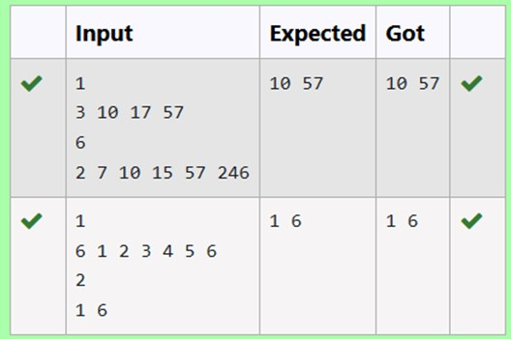

RESULT:

Hence the above program has been executed successfully.

|  |  |
| --- | --- |
| **Ex. No. : 6.5** | **Date: 17.09.24** |
| **Register No.: 230701363** | **Name: D.THEEPAK PALANI KUMAR** |



AIM:

Given an array A of sorted integers and another non negative integer k, find if there exists 2 indices i and j such that A[j] - A[i] = k, i != j.

Input Format:

First Line n - Number of elements in an array Next n Lines - N elements in the array k - Non - Negative Integer

Output Format:

1 - If pair exists

0 - If no pair exists

Explanation for the given Sample Testcase:

YES as 5 - 1 = 4

So Return 1.

ALGORITHM:

Step 1: Start

Step 2: Declare n, k and read the input values

Step 3: Create an array arr of size n and read its values

Step 4: Iterate through the array using nested loops to check if there is any pair whose difference is equal to k. If found, return 1. If no such pair is found, return 0 Step 5: Print the result and end the program

PROGRAM:

#include <stdio.h> int checkpair(int arr[],int n,int k){ for (int i=0;i<n;i++){ for (int j=i+1;j<n;j++){ if(arr[j]-arr[i]==k){ return 1;

} else if(arr[j]-arr[i]>k){ break;

}

}

}

return 0;

}

int main(){ int n, k; scanf("%d", &n); int arr[n]; for (int i=0;i<n;i++) { scanf("%d",&arr[i]);

}

scanf("%d",&k); int result=checkpair(arr,n,k); printf("%d\n",result);

}

OUTPUT:

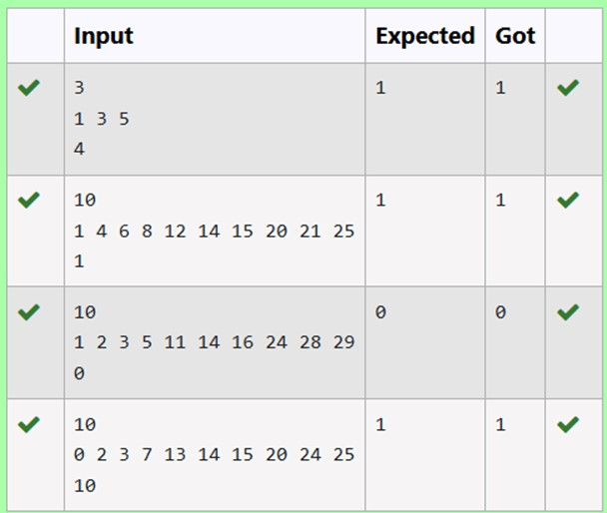

RESULT:

Hence the above program has been executed successfully.

|  |  |
| --- | --- |
| **Ex. No. : 6.6** | **Date: 17.09.24** |
| **Register No.: 230701363** | **Name: D.THEEPAK PALANI KUMAR** |



AIM:

Given an array A of sorted integers and another non negative integer k, find if there exists 2 indices i and j such that A[j] - A[i] = k, i != j.

Input Format:

First Line n - Number of elements in an array Next n Lines - N elements in the array k - Non - Negative Integer

Output Format:

1 - If pair exists

0 - If no pair exists

Explanation for the given Sample Testcase:

YES as 5 - 1 = 4

So Return 1.

ALGORITHM:

Step 1: Start

Step 2: Declare n, k and read the input values

Step 3: Create an array arr of size n and read its values

Step 4: Use two pointers i and j to iterate through the array, checking if the difference between arr[j] and arr[i] is equal to k. Adjust the pointers based on the value of the difference

Step 5: Print the result

PROGRAM:

#include <stdio.h> int checkpair(int arr[],int n,int k){ int i=0,j=1; while(j<n){ int diff=arr[j]-arr[i]; if (diff==k && i!=j){ return 1;

}

else if(diff<k){ j++;

}

else{ i++;

} if(i==j){ j++;

}

}

return 0;

}

int main(){ int n,k; scanf("%d",&n); int arr[n]; for (int i=0;i<n;i++){ scanf("%d",&arr[i]);

}

scanf("%d",&k); int result=checkpair(arr,n,k); printf("%d\n",result);

}

OUTPUT:

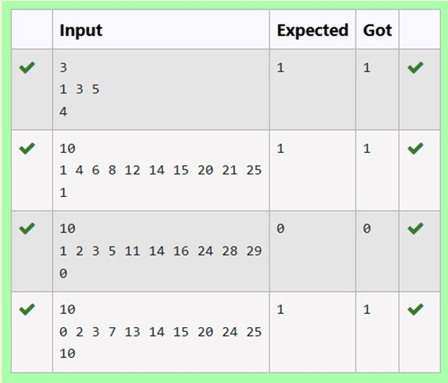

RESULT:

Hence the above program has been executed successfully.